[](https://energiasocial.co/snetlatam.html)

README _ 070223

**Milestone #2 @SIngularityNET LATAM Community DFR3-MKT-4 Proposal.**

Title ‘Crafting Compelling Content And Blog Creation.’

**Deliverables:** [#M2 _ DELIVERABLES LATAM SNET COMMUNITY _ 080224](https://drive.google.com/drive/folders/1LJxY7N24zfq8g-kp-KEe4epJytY6oFwr?usp=sharing)

**Deliverable #1/2 Description:** Create localized, high-quality blog articles in Spanish that focus on the unique needs and interests of each country's developer ecosystem.

-Set up dedicated blog sections on the SingularityNET website for each country.

**MIRO BOARD:**

**SingularityNET Latam Community Content Strategy & Schedule / 3 Months**

<https://miro.com/app/board/uXjVNvzWcOo=/?share_link_id=379859655806>

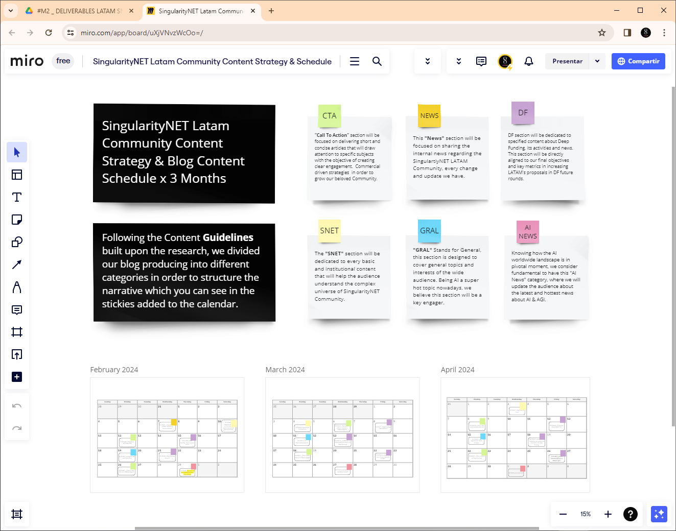

**SingularityNET Latam Community Blog Content Schedule / 3 Months:**

In the following folders you will find a total of 31 articles that will make up the content, blogs and posts of our communication strategy during the next 3 months. Incorporating images and going through a final review and editing process when they are published according to the scheduled calendar.

[1. BLOG CONTENT _ FEBRUARY _ 080224](https://drive.google.com/drive/folders/1fzKRN61rfmWtgvX9CeFSQYs6KxRaTpFh?usp=drive_link)

[2. BLOG CONTENT _ MARCH _ 080224](https://drive.google.com/drive/folders/1lpF-kWtnqZIPHKekrXaxDIf782DpM2K1?usp=sharing)

[3. BLOG CONTENT _ APRIL _ 080224](https://drive.google.com/drive/folders/1yxYyF5L4VbqzLAnZLN06M9BdsbpNwmLT?usp=sharing)

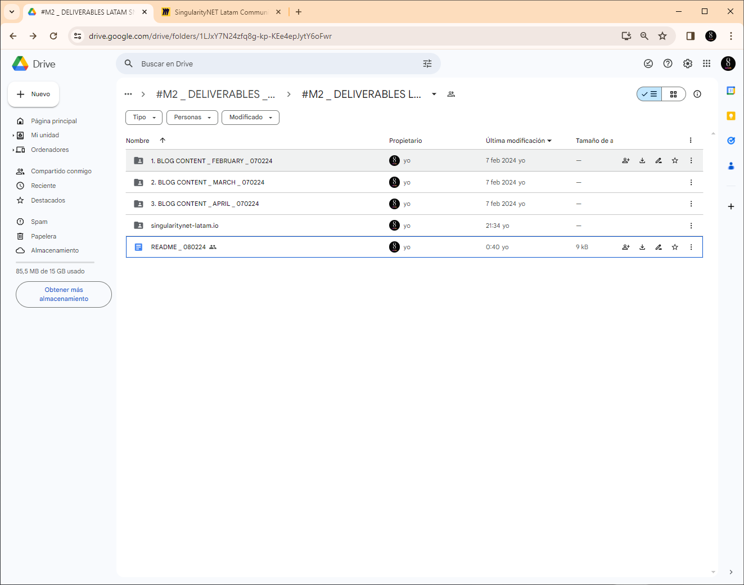

**MEDIUM Profile:** <https://medium.com/@singularitynet.latam>

Following the Content Guidelines built upon the research, we divided our blog production into different categories in order to structure the narrative which you can see in the stickies added to the calendar.

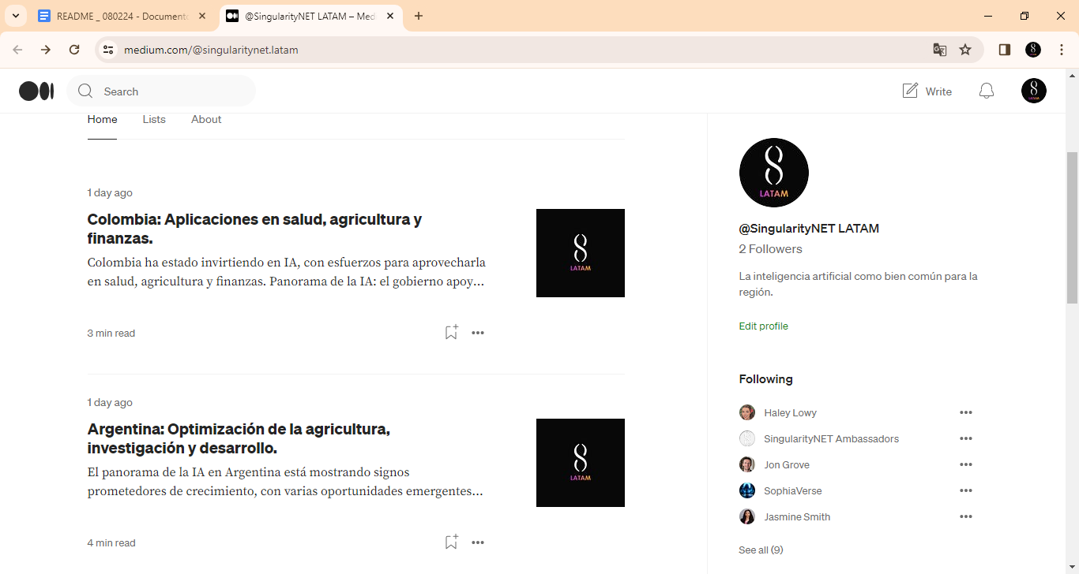

Integrate the calendar [Google Calendar Link](https://calendar.google.com/calendar/u/0?cid=MDdiZDczNTRkNTg4NDg1NmJmZjBhOGQ5Y2MwODlkYjMxNWY4NTdiNzQ0ODdjZDAyNGIwOTNjY2JmOGQyZWU0MkBncm91cC5jYWxlbmRhci5nb29nbGUuY29t)

Follow up our blog and content updates, download and integrate the ‘@SingularityNET LATAM Community Content Calendar’

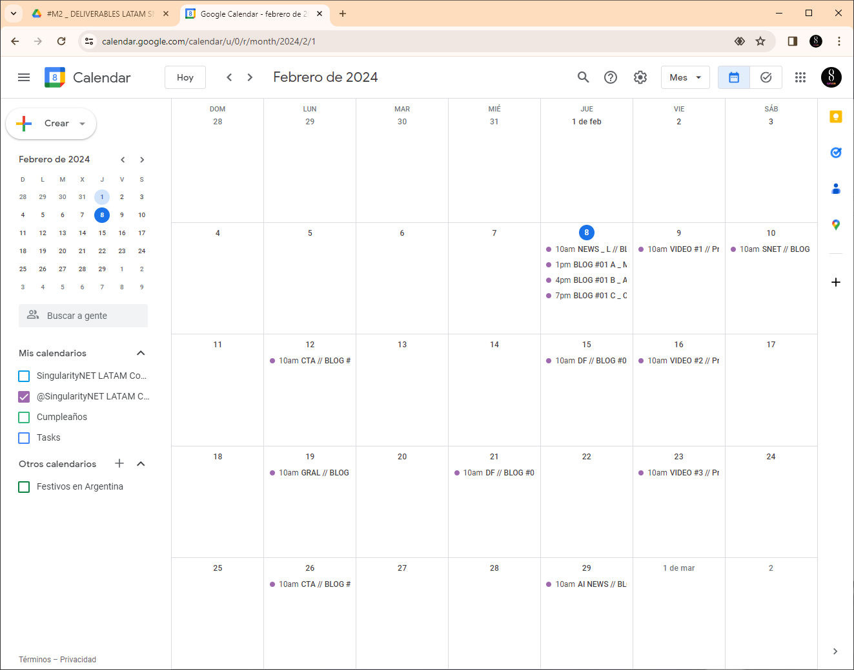

**Deliverable #3**

Description: Development of LATAM SingularityNET website.

[singularitynet-latam.io](https://energiasocial.co/snetlatam.html) / [html > development files](https://drive.google.com/drive/folders/109dtFrY8wQH9eLyXnKF3OfCxUN6ije_n?usp=sharing)

[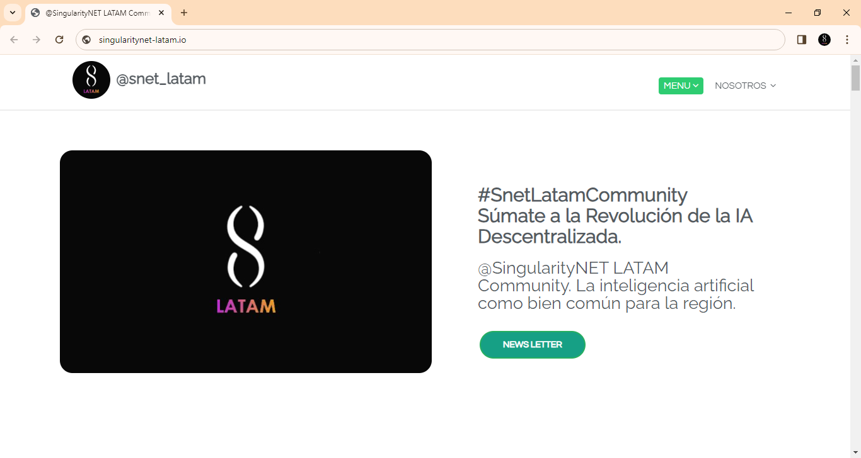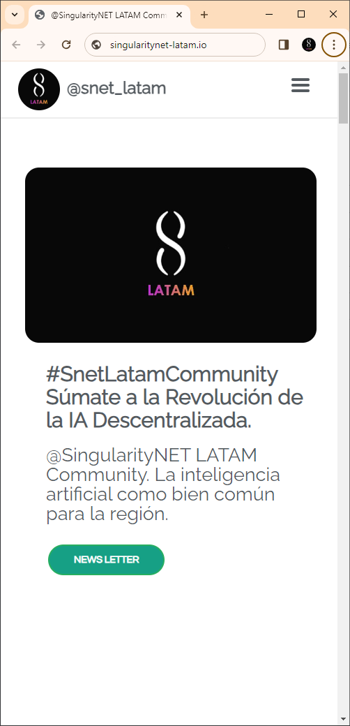](https://energiasocial.co/snetlatam.html)

[singularitynet-latam.io](https://energiasocial.co/snetlatam.html) /

LATAM SNET COMMUNITY LANDING PAGE _ 080224

#SnetLatamCommunity / Súmate a la Revolución de la IA Descentralizada.

La inteligencia artificial como bien común para la región.

[html > development files](https://drive.google.com/drive/folders/109dtFrY8wQH9eLyXnKF3OfCxUN6ije_n?usp=sharing)

With a dynamic responsive design, the site integrates functionalities from different vendors including, blogs, newsletter, sections focused on onboarding new participants and proposers for the Deep Funding Program, putting special focus to educate, to disseminate and spread the message the SingularityNET vision and mission, ecosystem, AI service platform and AGIX benefits. Integrating different functionalities the site looks to engage in different ways with the user and community members. The development, a live document will evolve in its capabilities and functions with the project and the community in the following phases.

The @SingularityNET LATAM Community landing page will be a space to unify our message focused on the LATAM community, exposing the different narrative lines outlined according to the research carried out by the team to amplify the impact of our actions and generate engagement and response to our marketing strategies and CTAs (call to action).

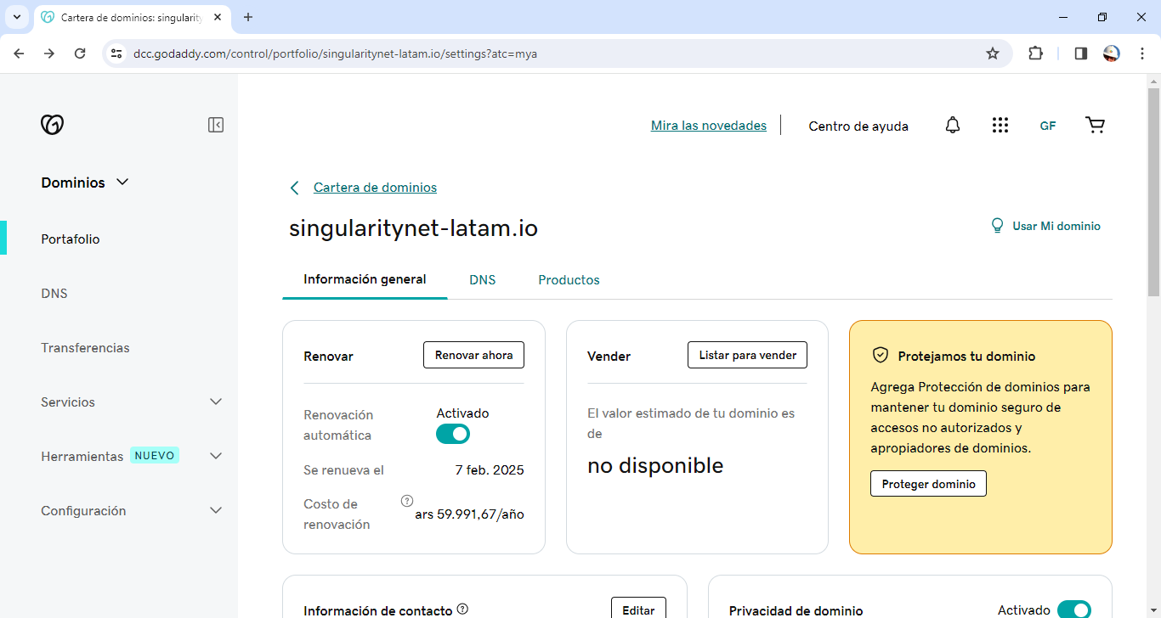

At the time of this milestone submission, the landing page has been deployed and uploaded to our FTP. Attached, you will find the documentation that validates the **domain purchase and the active hosting service activation process.** At this moment, the service provider is activating the IP and once this technical requirement process has been completed (24/48 hours) the team will proceed to assign the new root document for the new domain singularitynet-latam.io for its final activation, the process was started yesterday. [Purchase invoice](https://drive.google.com/file/d/12heYe5IuU9iPBOYub0-2QrxuIhIV9Zbs/view?usp=drive_link) . During this technical time required by the hosting service provider, the site is parked hosted within the @energiasocial platform, a lead project associated with the SingularityNET LATAM Community initiative.

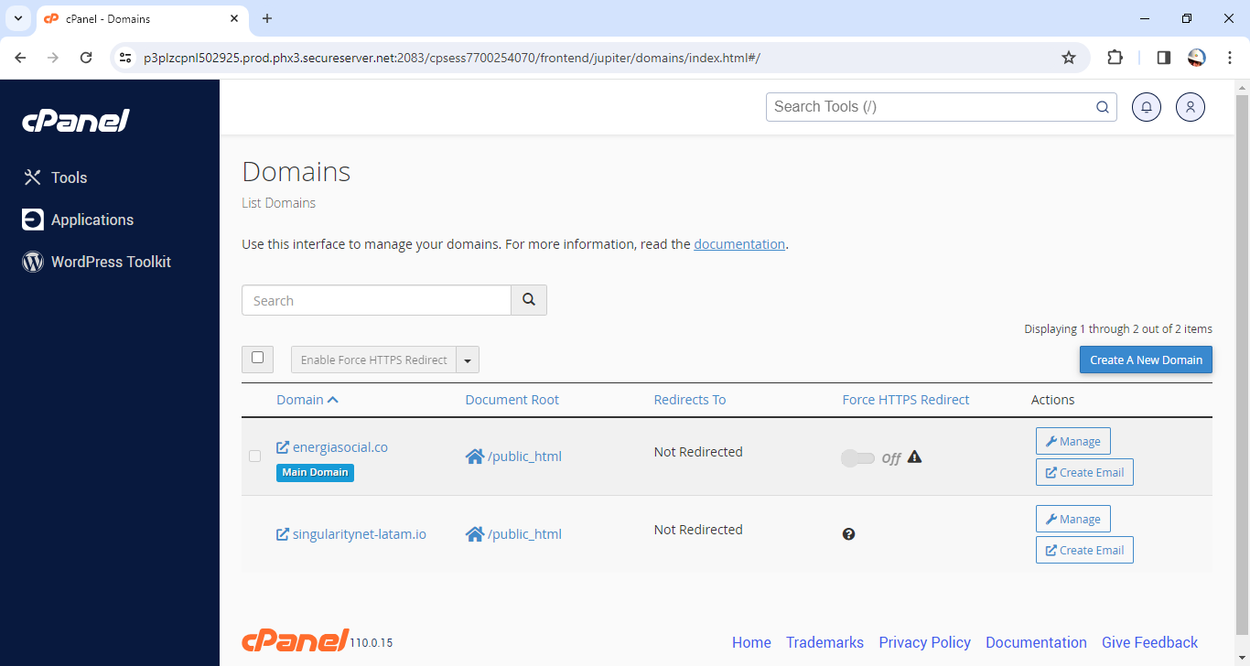

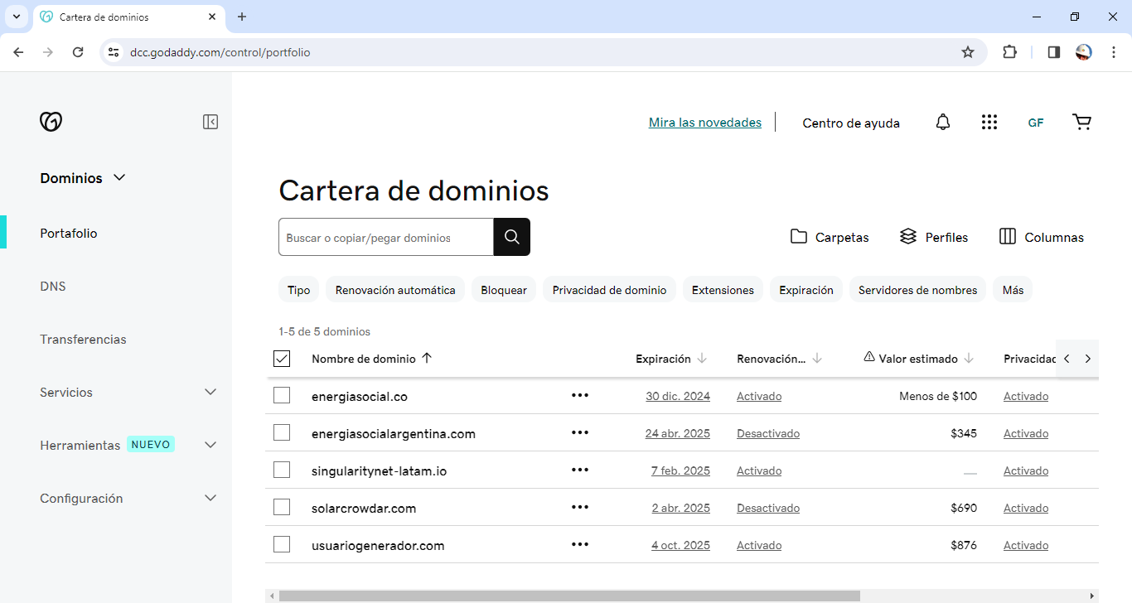

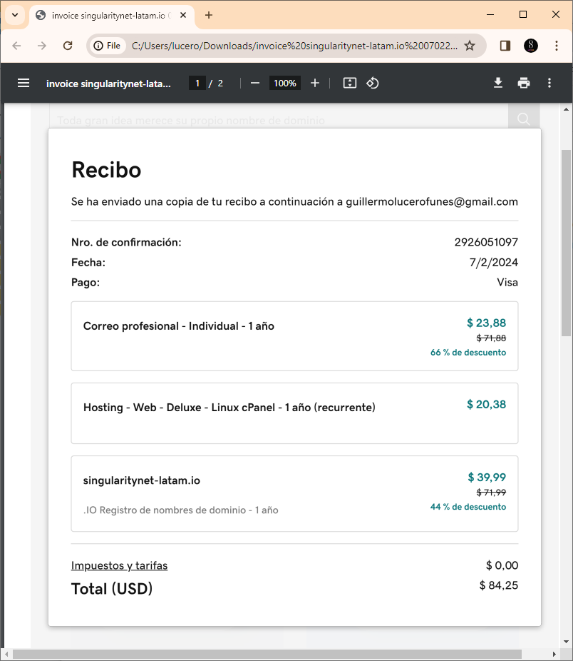

We have added an institutional email to the purchase in order to achieve the necessary formality to present the SingularityNET LATAM community in the government, institutional, educational and corporate spheres where we aspire to establish links and generate strategic alliances for the benefit of SingularityNET and its ecosystem.

Developed by:

**Ines Gavina /** Marketing and Communication Manager at @energiasocial

Content creator and creative brand producer. Working in expanding the transformative power of renewable energy and social businesses across the LATAM region.

**Guillermo Lucero /** Founder and CEO at @energiasocial. Specialist in renewable energy and sustainable social development strategies. Working in the development of new business models for technology innovation applied to comprehensive triple impact strategies with @mercadolibre in the LATAM region.

for **LATAM @SingularityNET Community**

<https://deepfunding.ai/proposal/latam-singularitynet-community/>

Creating and growing a vibrant and high-spirited community of talented LATAM innovators for decentralized AI revolution

[singularitynet-latam.io](https://energiasocial.co/snetlatam.html)

[singularitynet.latam@gmail.com](mailto:singularitynet.latam@gmail.com)

<https://github.com/singularitynet-latam>

<https://linktr.ee/singularitynet.latam>

<https://twitter.com/SNET_Latam>